START HERE

Doctoral

Portfolio

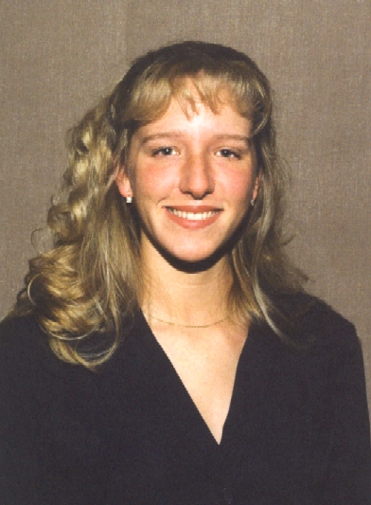

Sherri A. Sharp
Previously: S. A. Galloway

Table of Contents

To the Top

Personal
Application for Psychology Internship LINK
Curriculum Vita LINK

School Psychology
School Report – Case 1 LINK
School Report – Case 2 LINK
Clinical Report – Case 1 LINK
Clinical Report – Case 2 LINK

Clinical Report – Case 3 LINK
Clinical Report – Case 4 LINK

Consultation
Philosophy LINK

Counseling
Populations LINK
Cases LINK

Neuropsychological
Populations LINK
Report – Case 1 LINK
Report – Case 2 LINK
Report – Case 3 LINK

To the Top

